**MEMORY AND PROGRAMMABLE LOGIC**

**Field Programmable Gate Array (FPGA)**

* The hardware environment created for making a device programmable.
* High level language **->** Hardware instructions **->** Logic gates
* Various logics are separated via fabrics in processer.

**FPGA VS Microcontroller**

* FPGA can contain many microcontrollers.
* Microcontrollers have fixed possible instructions, whereas FPGA creates one.
* **DSP:** Digital signal processing

**Facts**

* FPGA can **handle a lot** of data efficiently (thus used in PCs).
* Remember ASIC.
* Some FPGAs are used for very specific software application.

**Advantages for FPGA**

* Can be customized.
* Can be added to CPU as **modification**.

**Hardware Description Language (HDL)**

* Some HDL are Verilog, VHDL etc.
* **VHDL:** Very highly description language.
* Syntaxes may look like Python or C.
* Not executed in sequence, rather **all at once**.

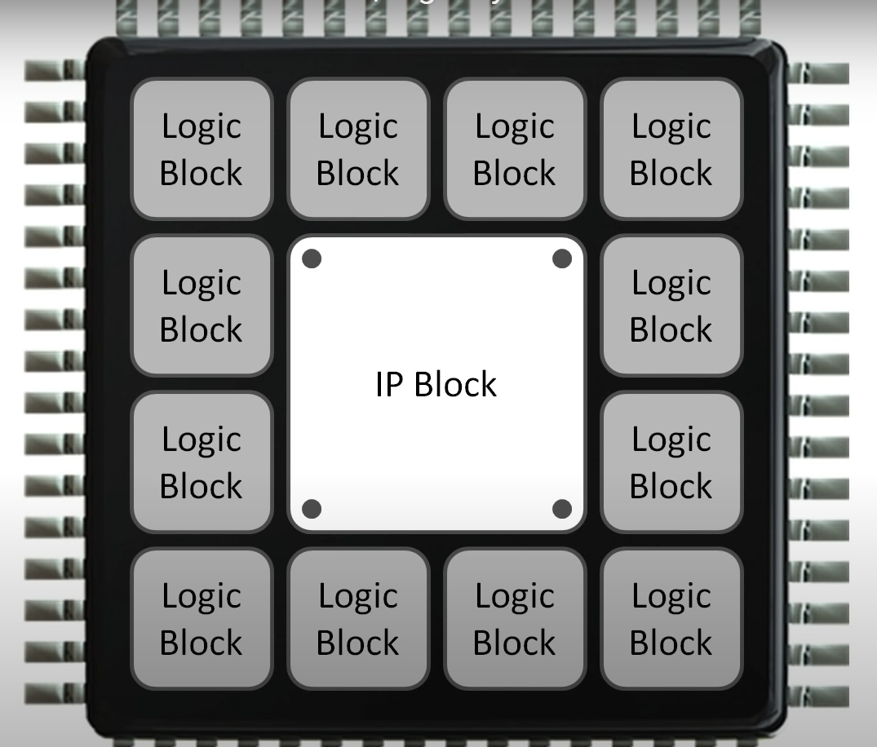

* **IP Block** is for the user to create their own complicated logic.

**ROM Programming**

* Non-volatile.
* SSD/HDD are **not** ROM.
* Stores a software called firmware (BIOS).
* Runtime for OS = JRE for Java
* **Types of ROM:-**
  + **Mask ROM:**
    - Data imprinted at the time of manufacturing.
    - Basic definition of ROM.
  + **PROM:**
    - All bits are by default 1.
    - We fuse bits (burn) in order to program it.
  + **EPROM:**
    - Erasable/reprogrammable using UV light.
  + **EEPROM:**
    - Stores small amount of data.
    - Bits are erased/reprogrammed using electric signals.
    - Also through field electron emission.
    - **1 bit** of data can be changed at a time.
    - **Ex:-** Flash drives etc.
  + **Flash ROM:**
    - **Same** as ROM, but with only one difference.
    - **512 bytes** of data can be changed at a time.

**Benefits of EEPROM**

* Compact
* Fast
* Large storage
* Reprogrammable

**Programming Logic Device (PLD)**

* Is an IC which includes **transistors**.
* ICs are added up to make up a whole computer.
* **Internal logic diagram example:**

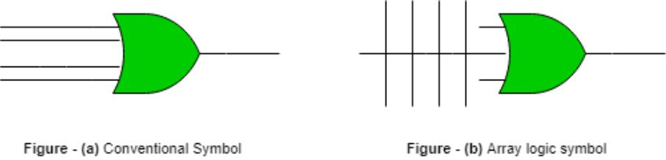

**Block Structure of ROM**

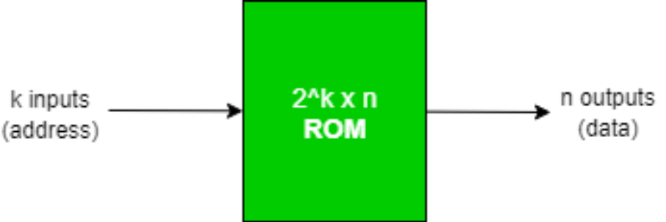

* **k input** lines (address lines).
* **2k output** lines.
* Accesses address of data required by the user.
* Also known as **2k ROM**.

**Internal Structure of ROM**

* Consists of **decoders** and **OR** gate.
* **Inputs** are in **binary** form.
* **Outputs** are in **decimal** form.
* Decoder takes **l inputs**, and has **2l outputs**.
* And these outputs serve as **inputs of OR** gates.

**Programming ROM**

* **For 4 x 4 ROM:**

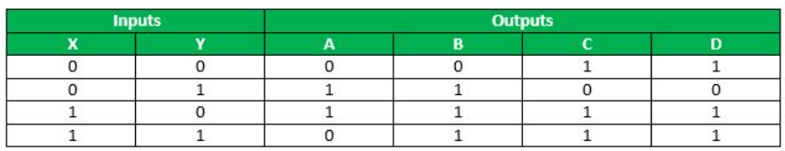

**Steps to Program ROM**

* **Step 1:** Connect all possible connections.

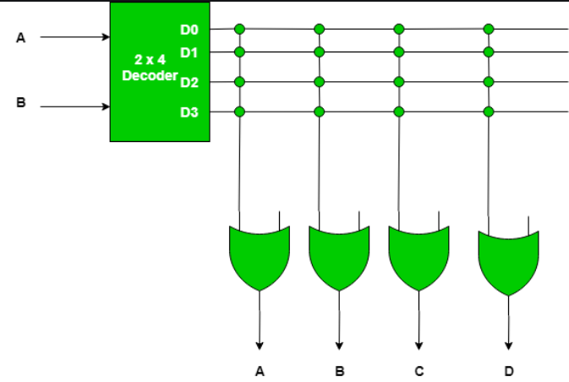

Each of these cross connections are known as **crosspoint**.

* **Step 2:** Now make changes in connections as per the truth table.

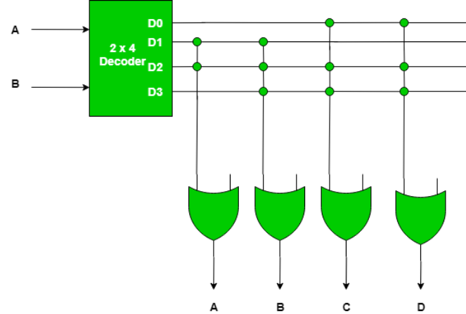

* In order to make changes in the data, one must blow up the fuse using high voltage.

**PLA**

* Fixed logical architecture.
* Can be reprogrammed/reconfigured.
* Contains AND gates followed by OR.
* Doesn’t provide full decoding to variables (but RAM do).
* Also uses buffers sometimes.

**PLD**

* **Unprogrammed** at the time of manufacturing.
* Made programmable **through PLA**.

**Comparison of Various PLDs**

* **PLA:** Contains programmable AND and OR gate arrays.
* **PAL:** Programmable AND but fixed OR.
* **RAM:** Fixed AND but programmable OR.

**PLA Block Diagram**

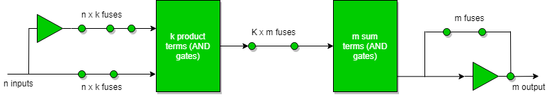

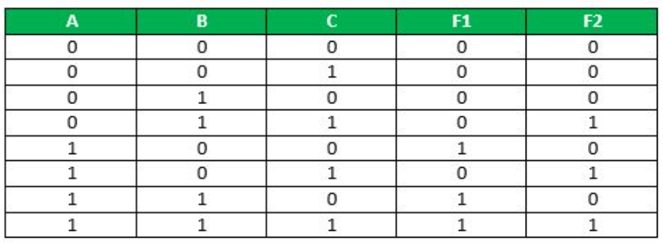

**Merit & Demerit of PLA**

* **Merit:** Flexibility (both gates are programmable).
* **Demerit:** Complexity.

**Working of PLA**

* **Programming:** User defined logics.
* **Product term generation:** Inputs are applied on AND gates (produces products).
* **Sum term generation:** *now you know*

**PLA Applications**

* Provides control over datapath
* Counter
* Decoder
* Keyboards

**PAL**

* Has limited AND gates.
* Contains **small PROM**.
* There are some advantages & disadvantages of PAL.

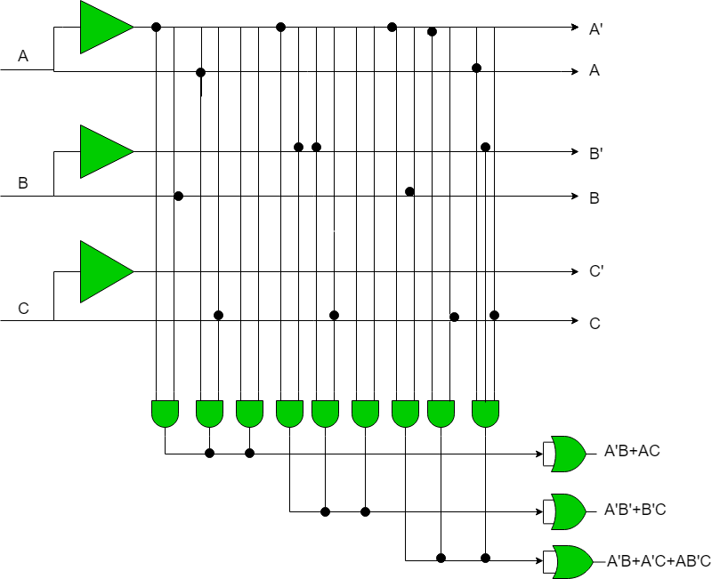

**Types of Memory**

* **Primary memory:**
  + Directly accessed by processor.
  + Stores data currently in action by computer.
  + Low storage.
  + **Two types:** RAM, ROM.
* **Secondary memory:**
  + Permanently stores data.
  + High storage.
  + Non-accessible from CPU.
  + **Four types:** Hard disk, CD, DVD, floppy disk.

**RAM**

* Data can be read, written and erased multiple times.
* Volatile memory.
* Also known as **main memory**.
* **Two types:-**
  + **SRAM**
    - Static-RAM.
    - Stores data sensing pattern of **6-transistor memory cell**.
  + **DRAM**
    - Dynamic-RAM.
    - Stores data sensing pattern of **pairs of transistors & capacitors**.

**ROM**

* Prerecorded data.
* Retains data even when computer turned OFF (non-volatile).
* Used in embedded parts.
* Initializes when power is supplied to computer.
* Is fixed on motherboard.
* Stores BIOS, which checks status of connected devices.

**RAM v/s ROM Differences**

**\*consider primary v/s secondary\***

* **RAM:** Reads + Writes
* **ROM:** Read only.
* **RAM:** High speed.
* **ROM:** Low speed.
* **RAM:** Data easily accessed by CPU.
* **ROM:** Difficult to access data by CPU.
* **RAM:** Comparatively high capacity.
* **ROM:** Comparatively low capacity.
* **RAM:** Used in storing cache.
* **ROM:** Used in microcontrollers.
* **RAM:** Expensive.
* **ROM:** Cheap.

**RAM Merits & Demerits**

1. **Advantages:-**
   1. Volatile.
   2. Flexibility (can be expanded).
2. **Disadvantages:-**
   1. Volatile.

**ROM Merits & Demerits**

1. **Advantages:-**
   1. Stability.
   2. Security.